A Progress Report

on

Medical Image Segmentation

carried out as part of the Minor Project IT3270 Submitted by

Aaditya Sharma

199302117

Nikhil Bhatnagar

199302121

VI-IT

in partial fulfilment for the award of the degree

of

Bachelor of Technology

In

Information Technology



Department of Information Technology
School of Computing and IT
Manipal University Jaipur
April 2022
Abstract

The human brain is the major controller of the humanoid system. The abnormal growth and division of cells in the brain lead to a brain tumor, and the further growth of brain tumors leads to brain cancer. CT scans, X-Ray, and MRI scans are the common imaging methods among magnetic resonance imaging (MRI) that are the most reliable and secure. MRI detects every minute objects. Our paper aims to focus on the use of different techniques for the discovery of brain tumor using brain MRI.

In this project, we make use of MRI images of brain tumor and its correspondent mask images to train our model to generate accurate results on predicting and segmenting these tumors. We'll be using the Convolution Neural Network (CNN) 'Unet' for achieving the same. Convolution Neural Network (CNN) segmentation techniques for reliable detection of the tumor region.

List of Figures

S.No | Title | Page No.
1 | Comparison of T1 vs T2 vs Flair | 7
2 | The 3 different kinds of tumor in the given dataset | 7
3 | Frequency of tumors in dataset | 8
4 | CNN Architecture | 9
5 | Flowchart for system Architecture | 11
6 | U Net Architecture | 14
7 | Bar Graph for Schedule of work | 16

Table of Contents

Abstract 2
List of figures 3

- Introduction 5
    - Problem Statement 6
    - Objectives 6
    - Scope of Project 7

  - Analysis 10
    - Literature Review 10

  - System Design & Methodology 11
    - System Architecture (Block Diagram) 11
    - Development Environment 12
    - Methodology: Algorithm/Procedures 14

- Work Done
4.1. Work done till date 15
4.2. Work left 15
4.3 Results and Discussion (If done) 15
4.2 Bar chart for Schedule of work 16

- Conclusion and Future Plan 16
- References 17

1. Introduction

Image segmentation is typically used to locate objects and boundaries (lines, curves, etc.) in images. More precisely, image segmentation is the process of assigning a label to every pixel in an image such that pixels with the same label share certain characteristics. The result of image segmentation is a set of segments that collectively cover the entire image, or a set of contours extracted from the image. When applied to a stack of images, typical in medical imaging, the resulting contours after image segmentation can be used to create 3D reconstructions with the help of interpolation algorithms like marching cubes. Each of the pixels in a region is similar with respect to some characteristic or computed property, such as colour, intensity, or texture.

In digital image processing and computer vision, image segmentation is the process of partitioning a digital image into multiple image segments, also known as image regions or image objects (sets of pixels). The goal of segmentation is to simplify and/or change the representation of an image into something that is more meaningful and easier to analyse. Detection of brain tumor using a segmentation approach is critical in cases, where survival of a subject depends on an accurate and timely clinical diagnosis. Gliomas are the most found tumours having irregular shape and ambiguous boundaries, making them one of the hardest tumours to detect. Our system also covers Meningioma and Pituitary Tumor which are some of the most common forms of brain tumor usually found.

    - Problem Statement

To automate the process of segmenting brain tumor regions in MRI images by implementation of Convolutional Neural Network.

A UNet based model that will be able to accurately locate the tumor regions in brain and perform semantic segmentation for obtaining accurate output images for the same.

    - Objectives

- Understanding how to implement theory to practice. To choose the right Dataset for our project so that the MRI images are clear and sharp.

- Normalize the images by subtracting the mean of each feature and a division of standard deviation to obtain a suitable range of pixel values for easy use.

- To understand how to implement U-Net architecture to build our model upon and generate accurate results by training it on the dataset. We will also be working upon specific methods to increase accuracy of our U-net model by applying some skip functions between the convolutional and max pooling layers.

- Finally, we aim to device a fully working neural network model to automate the process of segmentation of different tumor regions that could be present in the brain and develop it to the point where it can be used in the medical image domain for the welfare of the community.

    - Scope of Project

MRI Image acquired from dataset
This brain tumor dataset containing 3064 T1-weighted contrast-enhanced images from 233 patients with three kinds of brain tumor: meningioma (708 slices), glioma (1426 slices), and pituitary tumor (930 slices).

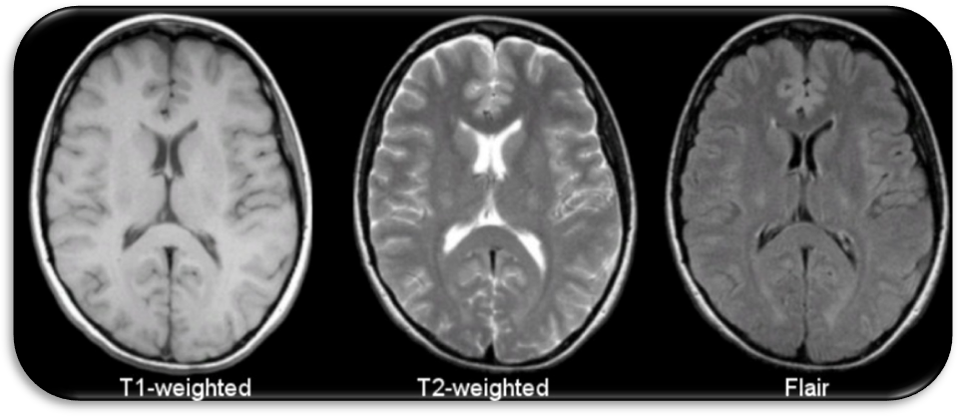
Figure 1: Comparison of T1 vs T2 vs Flair

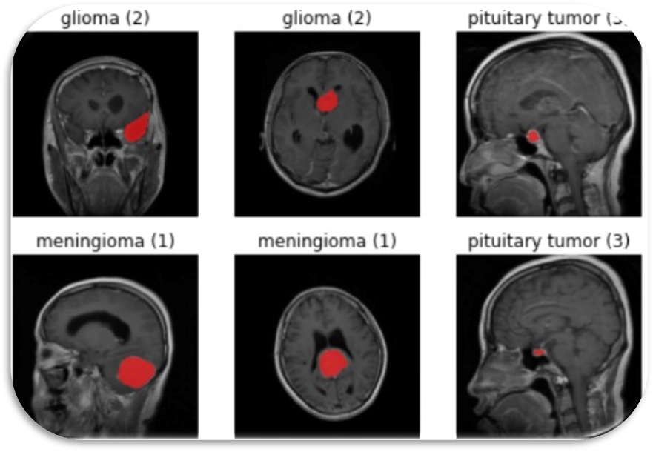
Figure 2: The 3 different kinds of tumor in the given dataset

Data Pre-processing

Data pre-processing transforms the data into a format that is more easily and effectively processed in data mining and machine learning.
There are several different tools and methods used for pre-processing data, including the following:
- sampling, which selects a representative subset from a large population of data.
- transformation, which manipulates raw data to produce a single input.
- denoising, which removes noise from data.
- imputation, which synthesizes statistically relevant data for missing values.
- normalization which organizes data for more efficient access.
- feature extraction, which pulls out a relevant feature subset that is significant in a particular context.

Image Segmentation
Image segmentation is a method in which a digital image is broken down into various subgroups called Image segments which helps in reducing the complexity of the image to make further processing or analysis of the image simpler. Segmentation in easy words is assigning labels to pixels. Segmentation has an important role in medical imaging as it helps in extracting the organ of interest.

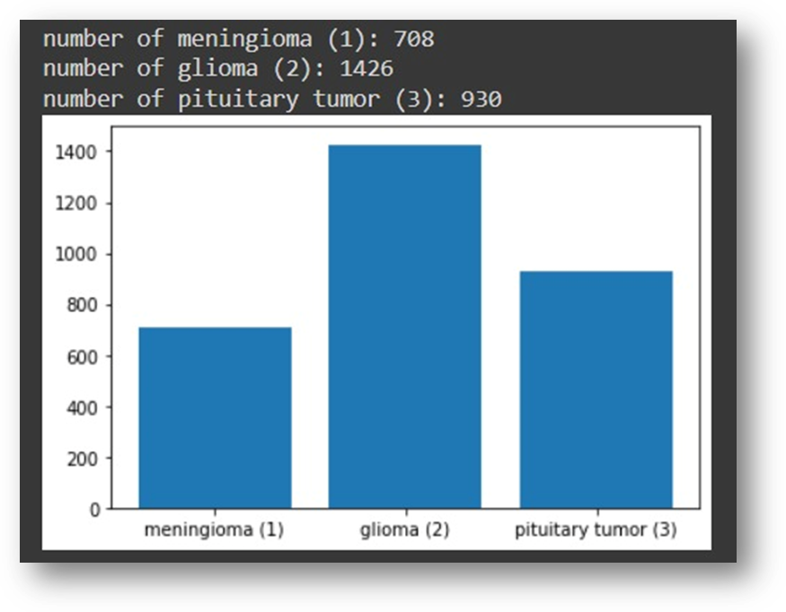
Figure 3: Frequency of tumors in dataset

CNN
Convolutional neural networks (CNNs) are deep neural networks that have the capability to classify and segment images. CNNs can be trained using supervised or unsupervised machine learning methods, depending on what you want them to do. CNN architectures for classification and segmentation include a variety of different layers with specific purposes, such as a convolutional layer, pooling layer, fully connected layers, dropout layers, etc.

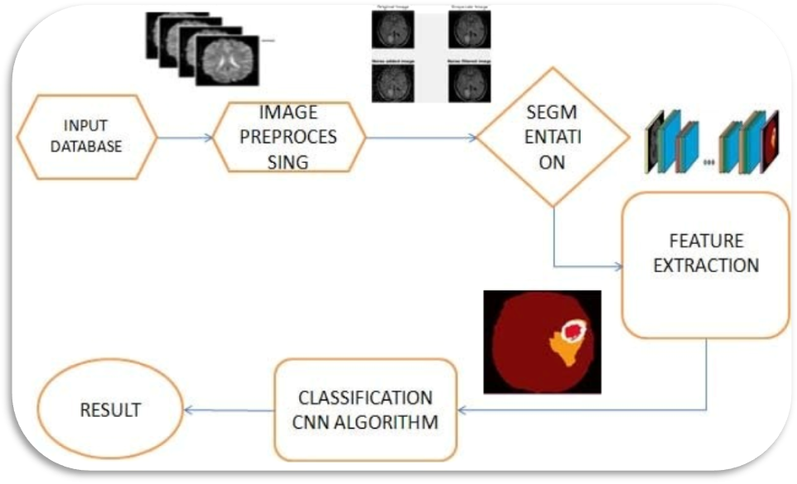
Figure 4: CNN Architecture

U-Net Architecture
U-Net is a convolutional neural network architecture that expanded with few changes in the CNN architecture. It was invented to deal with biomedical images where the target is not only to classify whether there is an infection or not but also to identify the area of infection.

- The task in image segmentation is to take an image and divide it into several smaller fragments. These fragments or these multiple segments produced will help with the computation of image segmentation tasks.
- For image segmentation tasks, another essential requirement is the use of masks. With the help of masking, which is basically a binary image consisting of zero or non-zero values, we can obtain the desired result required for the segmentation task.
- With this U-Net architecture, the segmentation of images of sizes 512X512 can be computed with a modern GPU within small amounts of time.

The intent of the U-Net is to capture both the features of the context as well as the localization. This process is completed successfully by the type of architecture built. The main idea of the implementation is to utilize successive contracting layers, which are immediately followed by the upsampling operators for achieving higher resolution outputs on the input images.

2. Analysis

2.1. Literature Review/Related Work (1-2 page)

- Asra Aslam, Ekram Khan, M.M. Sufyan Beg, Improved Edge Detection Algorithm for Brain Tumor Segmentation, Procedia Computer Science, Volume 58,2015, Pp 430-437, ISSN 1877-0509.
M. M. Sufyan et al. has presented a detection using enhanced edge technique for brain-tumor segmentation that mainly relied on Sobel feature detection. Their presented work associates the binary thresholding operation with the Sobel approach and excavates diverse extents using a secure contour process. After the completion of that process, cancer cells are extracted from the obtained picture using intensity values.

- Mahmoud, Dalia & Mohamed, Eltaher. (2012). Brain Tumor Detection Using Artificial Neural Networks. Journal of Science and Technology. 13. 31-39.
Dalia Mahmoud et al. [9] presented a model using Artificial Neural Networks for tumor detection in brain images. They implemented a computerized recognition system for MR imaging the use of Artificial Neural Networks. That was observed that after the Elman community was used during the recognition system, the period time and the 9-accuracy level were high, in comparison with other ANNs systems. This neural community has a sigmoid characteristic which elevated the extent of accuracy of the tumor segmentation.

- P.S. Mukambika, K Uma Rani, “Segmentation and Classification of MRI Brain Tumor,” International Research Journal of Engineering and Technology (IRJET), Vol.4, Issue 7, 2017, pp. 683 – 688, ISSN: 2395-0056.
Mukambika et al. proposed methodology for the subsequent stage’s classification of the tumor, whether it is present or not. Their proposed work represents the comparative study of strategies used for tumor identification from MR images, namely the Level set approach and discrete wavelength transforms (DWT) and K-method segmentation algorithms. After that phase, feature extraction is done followed SVM classification

- Priyanka Kadam , S.N. Pawar, “Brain Tumor Segmentation and It‟s Features Extraction by using T2 Weighted Brain MRI”, International Journal of Advanced Research in Computer and Communication Engineering ISO 3297:2007 Certified Vol. 5, Issue 7, July 2016.
The algorithm has been developed, which skips the areas of brain which do not suits the criteria of high intensity and high entropy, because these are the two main features of brain tumor in T2 weighted MRI. After that the image is rebuilt by using the extended maxima transformation, which helps to detect the brain tumor.

- Anil Singh Parihar, “A Study on Brain Tumor Segmentation Using Convolution Neural Network”, Department of Information Technology Delhi Technological University
The methods and their results have been studied for brain tumor segmentation using CNN. First Method involves brain tumor segmentation that tackles the diversity in multiple sites’, multiple scanner MRI images, using the method of intensity normalization which shows that it is relevant for good segmentation using MRI images

3. Methodology

3.1. System Architecture

MRI images acquired from dataset
Hdf5 storage was installed for incorporating and read the dataset

Basic pre-processing and normalization

Input images and their corresponding masks visualized
NumPy array for images and masks created

Data of various types of tumors present in the dataset
‘1’: ‘Meningioma(1)’
‘2’: ‘Glioma(2)’
‘3’: ‘Pituitary Tumor (3)’

U-Net model constructed for performing segmentation

Training and model fitting performed with specific loss function

Loss Function used = Binary Cross Entropy and Dice Loss combination

Results and outputs collected and evaluated

Flowchart for System Architecture

3.2. Development Environment. (H/w & S/W)

Software Requirements

- Python
Python is an interpreted, high-level, general purpose programming language created by Guido Van Rossum. Its language constructs and object-oriented approach aim to help programmers write clear, logical code for small and large-scale projects. Python is dynamically typed, and garbage collected. It supports multiple programming paradigms, including procedural, object-oriented, and functional programming.

- NumPy
NumPy is a general-purpose array-processing package. It provides a high-performance multidimensional array object, and tools for working with these arrays. It is the fundamental package for scientific computing with Python.
It contains various features including these important ones:
• A powerful N-dimensional array object
• Sophisticated (broadcasting) functions

- Keras
Keras is an open-source neural-network library written in Python. It is capable of running on top of TensorFlow, Microsoft Cognitive Toolkit, R, Theano, or Plaid ML. Designed to enable fast experimentation with deep neural networks, it focuses on being user-friendly, modular, and extensible. Keras contains numerous implementations of commonly used neural-network building blocks such as layers, objectives, activation functions, optimizers, and a host of tools to make working with image and text data easier to simplify the coding necessary for writing deep neural network code.

- PIP
It is the package management system used to install and manage software packages written in Python.

- TensorFlow
Tensor flow is a free and open-source software library for dataflow and differentiable programming across a range of tasks. It is a symbolic math library and is also used for machine learning applications such as neural networks. It is used for both research and production at Google.

- Google Colab
Colab allows anybody to write and execute arbitrary python code through the browser, and is especially well suited to machine learning, data analysis and education.

- Matplotlib
Matplotlib is a comprehensive library for creating static, animated, and interactive visualizations in Python.
the . mat extension are files that are in the binary data container format that the MATLAB program uses. The extension was developed by Mathworks and MAT files are categorized as data files that include variables, functions, arrays and other information.

- Hdf5 storage
HDF5 is a compressed format that is designed to support large, heterogeneous, and complex datasets. Supports Data Slicing: "Data slicing", or extracting portions of the dataset as needed for analysis, means large files don't need to be completely read into the computer’s memory or RAM. Version 7.3 of MAT-files uses HDF5 format, this format has a significant storage overhead to describe the contents of the file, especially so for complex nested cellarrays and structures. Its main advantage over previous versions of MAT-files is that it allows storing data larger than 2GB on 64-bit systems.

- OpenCV
OpenCV (Open-source computer vision) is a library of programming functions mainly aimed at real-time computer vision. Originally developed by Intel, it was later supported by willow garage then It sees (which was later acquired by Intel). The library is cross platform and free for use under the open-source BSD license. OpenCV supports some models from deep learning frameworks like TensorFlow, Torch, PyTorch (after converting to an ONNX model) and Caffe according to a defined list of supported layers. It promotes Open Vision Capsules. which is a portable format, compatible with all other formats.

Hardware Configuration
- Processor: Intel core i5 or above.
- 64-bit, quad-core, 2.5 GHz minimum per core
- Ram:
- Hard disk:
- Display: Dual XGA (1024 x 768) or higher resolution monitors
- Operating system: Windows

3.3. Method1ology: Algorithm/Procedures

CNN

CNN stands for Convolutional Neural Network, is used for the classification of images. The input images which are used in CNN are of 3 dimensions i.e., height, width, and number of channels. First two dimensions tell us the image resolution. And third dimension represents the number of channels (RGB) or intensity values for red, green and blue colors. Usually, images which are fed into the neural network are reduced in dimensions which reduce the processing time and avoid the problem of under fitting.

Convolutional Neural Networks (CNNs) are multi-layer feedforward networks specifically designed to recognize features in 2-dimensional image data. CNNs are primarily used for 2D image recognition, so we will illustrate their architecture on a 2D rectangular image consisting of pixels. Each pixel generally carries color information. Colon can be represented by multiple channels (e.g- 3 RGB channels). The essence of CNNs is the convolutions. The main trick with convolutional networks that avoids the problem of too many parameters is sparse connections

U Net Architecture

The UNET was developed by Olaf Ronneberger et al. for Bio Medical Image Segmentation. The architecture contains two paths. First path is the contraction path (also called as the encoder) which is used to capture the context in the image. The encoder is just a traditional stack of convolutional and max pooling layers. The second path is the symmetric expanding path (also called as the decoder) which is used to enable precise localization using transposed convolutions. Thus, it is an end-to-end fully convolutional network (FCN), i.e. it only contains Convolutional layers and does not contain any Dense layer because of which it can accept image of any size.

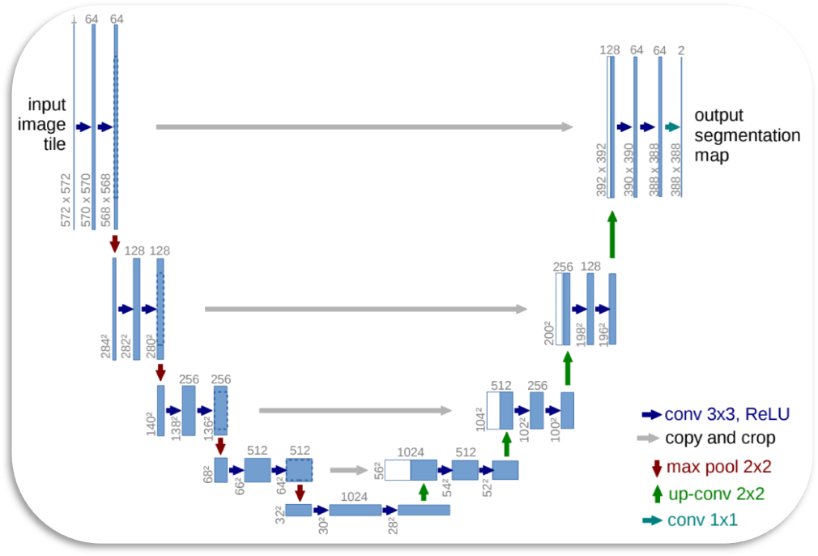
Figure 5: U Net Architecture
U-net architecture (example for 32x32 pixels in the lowest resolution). Each blue box corresponds to a multi-channel feature map. The number of channels is denoted on top of the box. The x-y-size is provided at the lower left edge of the box. White boxes represent copied feature maps. The arrows denote the different operations.

4. Work Done

4.1. Work done till date

- Acquired the right Dataset of MRI images and visualized it correctly with the help of Hdf5 storage for (.mat) formats. Plotted the corresponding masks of the input images and looked at how to go on about constructing the final output images.
- Created a graphical representation of the various types of Tumors present in the dataset and changed the images to gray scale.
- A functional U-Net model is being built to accurately segment the MRI images. Certain skip functions might be applied for more accuracy in results later.

4.2. Work left

- Trying to incorporate 3D volumetric features on MRI images
- Improve the functionality of the model on large datasets and improve the overall accuracy.

4.3 Results and Discussion

After constructing the UNet model for our segmentation task, work is in progress for training the model on this architecture. Successive tasks to be achieved are to incorporate the loss functions and successfully train the model with high accuracy to determine exact location of the tumor regions present in the MRI images.

4.4 Schedule of work

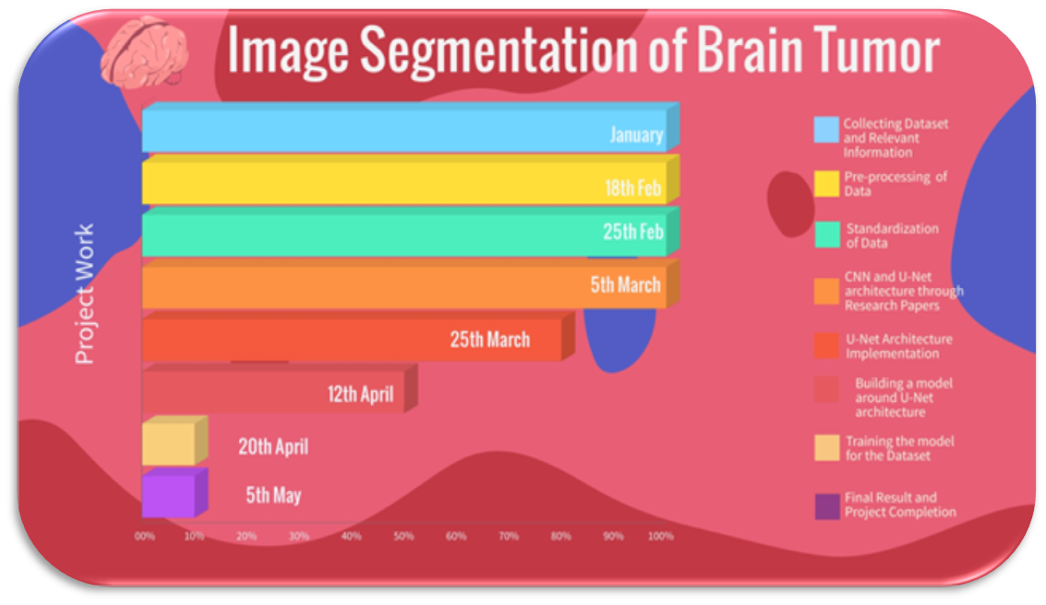
Figure 6: Bar Graph for Project Work

- Conclusion and Future Plan

After constructing the UNet model for our segmentation task, work is in progress for training the model on this architecture. Successive tasks to be achieved are to incorporate the loss functions and successfully train the model with high accuracy to determine exact location of the tumor regions present in the MRI images.

Future plans:

- Incorporate 3D volumetric features on MRI images
- Improve the functionality of the model on large datasets and improve the overall accuracy.

References

- Priyanka Kadam , S.N. Pawar, 2016, “Brain Tumor Segmentation and It’s Features Extraction by using T2 Weighted Brain MRI”, International Journal of Advanced Research in Computer and Communication Engineering ISO 3297:2007 Certified Vol. 5, Issue 7.

- Anil Singh Parihar, 2017,” A Study on Brain Tumor Segmentation Using Convolution Neural Network”, Proceedings of the International Conference on Inventive Computing and Informatics (ICICI 2017) IEEE Xplore Compliant - Part Number: CFP17L34-ART, ISBN: 978-1-5386-4031-9.

- Asra Aslam, Ekram Khan, M.M. Sufyan Beg, 2015, “ Improved Edge Detection Algorithm for Brain Tumor Segmentation”, Procedia Computer Science, Volume 58, , Pp 430-437, ISSN 1877-0509

- Mahmoud, Dalia & Mohamed, Eltaher. 2012 “Brain Tumor Detection Using Artificial Neural Networks. Journal of Science and Technology” 13. 31-39.

- P.S. Mukambika, K Uma Rani, 2017 “Segmentation and Classification of MRI Brain Tumor,” International Research Journal of Engineering and Technology (IRJET), Vol.4, Issue 7, pp. 683 – 688, ISSN: 2395-0056.

